Do you see it? :-)
你看到了吗？:-)

The "a" field has the wrong value!!! It should say:
这个“a”字段有了一个错误的值！！！它本该是：
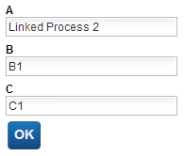
So .... what happened?
那么……到底发生了什么？

The answer can be found in the IBM BPM documentation found here:
我们可以从以下链接，来自IBM BPM文档寻求答案：

http://pic.dhe.ibm.com/infocenter/dmndhelp/v8r5m0/topic/com.ibm.wbpm.bpc.doc/modeling/topic/
declaring_variables_A.html

Here is what caught my eye:
我们可以看到：

Page 301

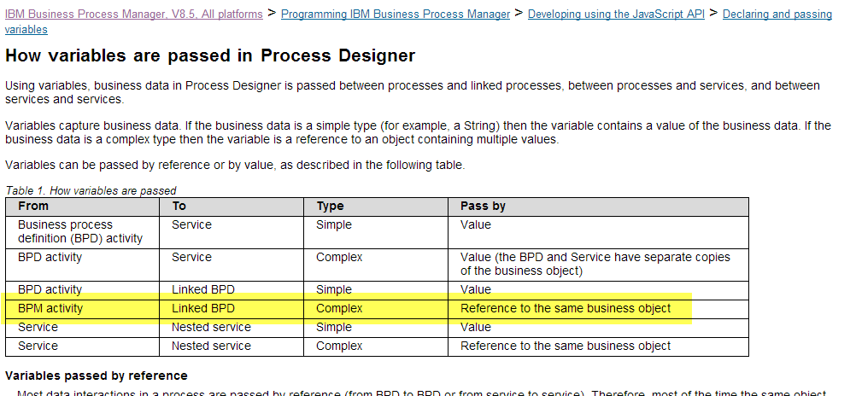
When we call from one process to another as a link, the variable is passed by reference and not by value (a copy).
当我们调用一个流程到另一个流程，就像一个链接，其变量的传递是通过引用而非值（副本）。

What this means ... is that our BPM process called "MyProcess" (see above) ... is logically the same as:
意思就是……BPM流程调用“MyProcess”（参照上面）……在逻辑上如同：
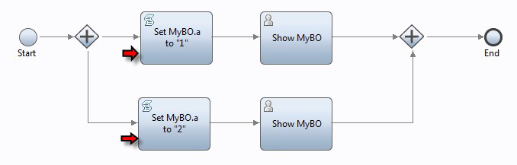
And if we look closely at this diagram, we see that the two marked activities BOTH set the same business object instance field to two different values ... in parallel and since one of them will run before the other in reality, the last one executed will set the single value ... and it is that single value that is shown in the Coaches.
如果我们仔细看上图，可以看到，这两个标记活动都设置了相同的业务对象变量，和有不同的值……并行的，实际上由于其中一个比另外一个先运行，后运行的将会设置为同一个值，而且这就是显示在页面上的值。

With this understanding in mind, we can now see how to avoid the problem ... have two business objects ... one for "Linked Process 1" and one for "Linked Process 2" ... and don't share the same business object between both.

在此理解的基础之上，我们现在可以避免这个问题……有两个业务对象，一个是“Linked Process 1”，另一个是“Linked Process 2”……在他们之间不要使用相同的业务对象。

Page 302

